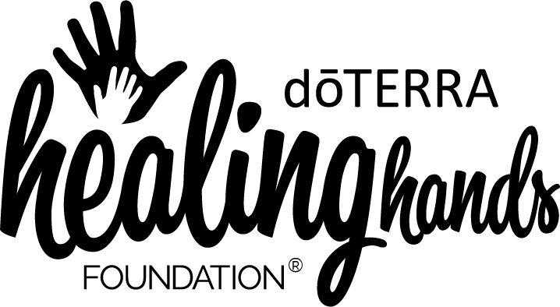

Emergency Hygiene Kit Application Form

General Information
doTERRA® 72 hour Emergency Hygiene kits are designed to provide relief to evacuees and people in need following a disaster. Each kit contains a supply of personal care items along with instructions for use in both English and Spanish. Wellness Advocates living in or near a disaster zone can request kits to distribute in their surrounding communities by completing this form. We recognize the time-sensitive nature of disaster requests and will do our best to meet your needs as quickly as possible.

Your Name:
ID Number:
Email Address:
Disaster:
Disaster Location:
Number of kits you are requesting:
Shipping Address:
Phone Number (in case of shipping questions):

Please note that you must be a Wellness Advocate, or be working with a Wellness Advocate, to qualify for a donation of doTERRA 72 Hour Emergency Hygiene Kits. You do not need to be affiliated with a nonprofit or NGO to qualify for a donation. At this time, we are only shipping Emergency Hygiene Kits to Wellness Advocates with addresses in the United States. Please assess the disaster in your community and request the number of kits that you need and are able to distribute (not to exceed 100 kits per Wellness Advocate and up to 200 if you are working as a team of Wellness Advocates).

Please send your completed form to healinghands@doterra.com

