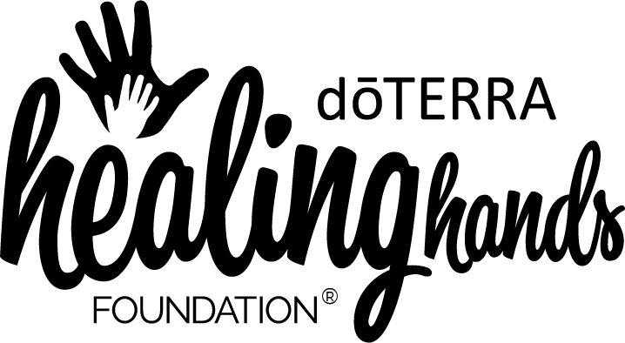

Product Request Application Form
[ORGANIZATION]

General Information
To be approved for a charitable product donation, you must be affiliated with a nonprofit or NGO. Please note that it can take up to 4 weeks to hear back about your product donation request, for both dHHF and doTERRA requests, and we do not expedite product donations.

Your Name:
ID Number:
Email Address:
Project Date:
Project Location:
Organization Name:
Organization EIN:

Project Information
Charitable product donations should be used to further the doTERRA Healing Hands Foundation mission to empower communities toward self-reliance. Please note that charitable product donations should support a cause, rather than a specific individual (e.g., these donations cannot be used to support an individual recovering from illness or surgery, a family suffering from the death of a loved one, replacing oils or products lost in a disaster, etc.).

Briefly describe the charitable cause you are asking the Healing Hands Foundation to contribute product to:

How will the product be used on this project?

How will this project help to empower individuals and communities toward self-reliance?

The dHHF mission supports causes in the following categories: micro-lending, access to healthcare, sanitation & clean water, providing educational opportunities, the fight against human trafficking, and emergency/disaster relief. In which category does your project fit, and how?

Logistics
As you know, a learning curve exists when introducing essential oils into a community. The dHHF wants to ensure that charitable product donations impact recipient communities in positive ways. For this reason, the Wellness Advocate requesting the product is responsible to hand-deliver these charitable donations so they can provide the accompanying training to the recipient community.

How are you planning to deliver this charitable product donation to the recipient community? How will the training take place?

Where would you like this project shipped? Please also provide an associated phone number. (Note: charitable product donations are only shipped within the United States. If you are a Wellness Advocate located somewhere other than the United States, please include your address and your doTERRA market)

Please identify the specific products you are requesting for this project, and complete the attached Product Request Form.

